C++ MINI PROJECT REPORT

**NAME** : MIHIR RAJESH PANCHAL

**SAP ID** : 57498200018

**ROLL NO** : T018

**SEM** : II

**BRANCH** : INFORMATION TECHNOLOGY

**SUBJECT** : PROGRAMMING IN C++

**SUBJECT CODE** : CPP198914

**“MARVEL AVENGERS FIGHTING SIMULATOR GAME”**

INDEX

1. OVERVIEW OF MINI PROJECT 03

2. CONCEPTS USED IN MINI PROJECT 04

3. EXPLANATION OF SOURCE CODE

* VARIABLES 05-07
* CLASS 08
* MEMBER FUNCTIONS 09
* MAIN FUNCTION 10-11

4. SOURCE CODE 12-39

5. OUTPUT 40-46

5. CONCLUSION 47

**1.** **OVERVIEW OF MINI PROJECT**

* The Name of the Mini Project is “Marvel Avengers Fighting Simulator Game”.
* The Flow of the mini project is as follows :

1. Choose Appropriate Action from main menu.
2. Choose your Avenger from listed OR have your customized Avenger with attacks.
3. Choose your Villain from listed OR have your customized Villain with attacks.
4. Choose Avenger’s attack and inflict Damage on Villain.
5. Continue the Fight until the Result of fight is not declared.
6. Select Desired Options from Main Menu or terminate the program.

**2.CONCEPTS USED IN MINI PROJECT**

1. Class and Object
2. Inheritance
3. Pointers
4. File Handling
5. Data Encapsulation
6. String Functions
7. Switch Case
8. For Loop, While Loop, Do While Loop
9. If Else Statements

**3.** **EXPLANATION OF SOURCE CODE**

* **VARIABLES**

INTEGER VARIABLES : (int)

1. hpa->Hitpoints of Avenger.
2. hpv->Hitpoints of Villain.
3. caa1->Customize Avenger Attack Damage 1
4. caa2->Customize Avenger Attack Damage 2
5. caa3->Customize Avenger Attack Damage 3
6. caa4->Customize Avenger Attack Damage 4
7. cvv1->Customize Villain Attack Damage 1
8. cvv2->Customize Villain Attack Damage 2
9. cvv3->Customize Villain Attack Damage 3

10.cvv4->Customize Villain Attack Damage 4

11.a1->Avenger Attack Damage 1

12.a2->Avenger Attack Damage 2

13.a3->Avenger Attack Damage 3

14.a4->Avenger Attack Damage 4

15.v1->Villain Attack Damage 1

16.v2->Villain Attack Damage 2

17.v3->Villain Attack Damage 3

18.v4->Villain Attack Damage 4

19.flag=0->For condition Checker

20.i->For Loop Iteration

Character Variables : (char)

1. na->Name of Avenger
2. nv->Name of Villain
3. cana1->Customize Avenger Name of Attack 1
4. cana2->Customize Avenger Name of Attack 2
5. cana3->Customize Avenger Name of Attack 3
6. cana4->Customize Avenger Name of Attack 4
7. cvnv1->Customize Villain Name of Attack 1
8. cvnv2->Customize Villain Name of Attack 2
9. cvnv3->Customize Villain Name of Attack 3

10.cvnv4->Customize Villain Name of Attack 4

11.choicea->Choice of Avenger

12.choicev->Choice of Villain

13.choice->Choice of Attack

14.name->Name

15.choicera->Choice for Rating

16.choicepa->Choice in Main Menu

17.guide->Choice for Game Guide

18.ch->For File Handling.

Float Variables : (float)

1. a->Reinitialising Value of hpv in Loop
2. b->Reinitialising Value of hpa in Loop
3. rate->Rating of the Game

* **CLASS**

1. There are two classes in the mini project namely :

1.class Marvel

2.class Fight

1. In the class Marvel, setter and getter functions are included to set and get Avenger’s and Villain’s Data.
2. Class Marvel is the Parent Class of Class Fight
3. Class Fight is the daughter class and is inheriting data from parent class Marvel
4. Main logic of the program is written in Class Marvel in member function fight();

* **MEMBER FUNCTIONS**

1. setchar();->Choosing Avenger From List
2. getchar();->Displaying Input of setchar(); function
3. setvill();->Choosing Villain from List
4. getvill();->Displaying Input of setvill();
5. matchup();->Initialising Variable values according to the choices made in setchar(); and setvill(); functions.
6. fight();->Main Logic of Program of a fight scene between Avenger and Villain.

* **MAIN FUNCTION**

1. The main function has a choice base flow for the main menu of the program.
2. The choices of main menu are as follows :
3. Play Game
4. Game Guide
5. Battle Log
6. Cheat Codes
7. Rate Game
8. Credits
9. Exit Game

1.Play Game

Member functions of Class Fight and Marvel are called to perform the main logic of the program

2.Game Guide

Information about Game characters is displayed in a choice based logic

3.Battle Log

Using File handling , History of Battle logs is stored in a text document and is viewed in the program.

4.Cheat Codes

Using Pointer Concept a Locker is created with Password ‘Avengers’ in which information about cheat codes is available

5.Rate Game

Using File Handling , Reviews and the Name of the Reviewer is stored in a text document and a choice of viewing the text document is available in the program

6.Credits

Information about the Developer of this program is available.

7.Exit Game

Program is terminated completely by this action.

**4.SOURCE CODE**

#include<iostream>

#include<fstream>

#include<stdlib.h>

#include<string.h>

using namespace std;

class Marvel

{

public:

int hpa,hpv;

char na[100],nv[100];

char cana1[100],cana2[100],cana3[100],cana4[100];

char cvnv1[100],cvnv2[100],cvnv3[100],cvnv4[100];

int caa1,caa2,caa3,caa4;

int cvv1,cvv2,cvv3,cvv4;

char choicea,choicev;

setchar()

{

cout<<"Marvel Avenger List : "<<endl;

cout<<"(1)Iron Man"<<endl;

cout<<"(2)Hulk"<<endl;

cout<<"(3)Thor"<<endl;

cout<<"(4)Captain America"<<endl;

cout<<"(5)Customize Avenger"<<endl;

cout<<"\nChoose Your Marvel Avenger (Number): ";

cin>>choicea;

cout<<"\n";

}

getchar()

{

if(choicea=='1')

{

cout<<"Avenger Choosen : Iron Man"<<endl;

hpa=220;

}

else if(choicea=='2')

{

cout<<"Avenger Choosen : Hulk"<<endl;

hpa=300;

}

else if(choicea=='3')

{

cout<<"Avenger Choosen : Thor"<<endl;

hpa=200;

}

else if(choicea=='4')

{

cout<<"Avenger Choosen : Captain America"<<endl;

hpa=260;

}

else if(choicea=='5')

{

cout<<"Customize Avenger : "<<endl;

cout<<"Enter Avenger Name (EX : Your Name) : ";

cin>>na;

cout<<"Enter Avenger Hitpoints (Number): ";

cin>>hpa;

cout<<"Enter Name of Attack 1 (EX : Thunder) : ";

cin>>cana1;

cout<<"Enter Damage of Attack 1 (Number): ";

cin>>caa1;

cout<<"Enter Name of Attack 2 (EX : Telepathy) : ";

cin>>cana2;

cout<<"Enter Damage of Attack 2 (Number): ";

cin>>caa2;

cout<<"Enter Name of Attack 3 (EX : Flamethrower) : ";

cin>>cana3;

cout<<"Enter Damage of Attack 3 (Number): ";

cin>>caa3;

cout<<"Enter Name of Attack 4 (EX : Punch) : ";

cin>>cana4;

cout<<"Enter Damage of Attack 4 (Number): ";

cin>>caa4;

}

else

{

cout<<"Wrong Input"<<endl;

cout<<"Try Again!!!"<<endl<<endl;

setchar();

getchar();

}

}

setvill()

{

cout<<"\nMarvel Villain List : "<<endl;

cout<<"(1)Thanos"<<endl;

cout<<"(2)Loki"<<endl;

cout<<"(3)Customize Villain"<<endl;

cout<<"\nChoose Your Marvel Villain (Number): ";

cin>>choicev;

cout<<"\n";

}

getvill()

{

if(choicev=='1')

{

cout<<"Villain Choosen : Thanos"<<endl;

hpv=480;

}

else if(choicev=='2')

{

cout<<"Villain Choosen : Loki"<<endl;

hpv=240;

}

else if(choicev=='3')

{

cout<<"Customize Villain : \n"<<endl;

cout<<"Enter Villain Name (EX : Enemy): ";

cin>>nv;

cout<<"Enter Villain Hitpoints (Number): ";

cin>>hpv;

cout<<"Enter Name of Attack 1 (EX : Kick) : ";

cin>>cvnv1;

cout<<"Enter Damage of Attack 1 (Number): ";

cin>>cvv1;

cout<<"Enter Name of Attack 2 (EX : Uppercut) : ";

cin>>cvnv2;

cout<<"Enter Damage of Attack 2 (Number): ";

cin>>cvv2;

cout<<"Enter Name of Attack 3 (EX : Takedown) : ";

cin>>cvnv3;

cout<<"Enter Damage of Attack 3 (Number): ";

cin>>cvv3;

cout<<"Enter Name of Attack 4 (EX : Smash) : ";

cin>>cvnv4;

cout<<"Enter Damage of Attack 4 (Number): ";

cin>>cvv4;

}

else

{

cout<<"Wrong Input"<<endl;

cout<<"Try Again"<<endl;

setvill();

getvill();

}

}

};

class Fight:public Marvel

{

public:

char choice;

char *avg[100],*vill[100];

char *na1[100],*na2[100],*na3[100],*na4[100];

char *nv1[100],*nv2[100],*nv3[100],*nv4[100];

int a1,a2,a3,a4;

int v1,v2,v3,v4;

float a,b;

matchup()

{

if(choicea=='1' && choicev=='1')

{

*avg={"Iron Man"};

*na1={"Laser Beam"};

*na2={"Power Drive"};

*na3={"Thruster Uppercut"};

*na4={"Repulsor Shot"};

a1=80;

a2=60;

a3=40;

a4=20;

*vill={"Thanos"};

*nv1={"Palm Breaker"};

*nv2={"Titan's Gaze"};

*nv3={"Insolence Crusher"};

*nv4={"Hand Bomb"};

v1=30;

v2=10;

v3=20;

v4=15;

fight();

}

else if(choicea=='1' && choicev=='2')

{

*avg={"Iron Man"};

*na1={"Laser Beam"};

*na2={"Power Drive"};

*na3={"Thruster Uppercut"};

*na4={"Repulsor Shot"};

a1=80;

a2=60;

a3=40;

a4=20;

*vill={"Loki"};

*nv1={"Energy Blast"};

*nv2={"Scepter"};

*nv3={"Hypnosis"};

*nv4={"Telekinesis"};

v1=50;

v2=30;

v3=20;

v4=35;

fight();

}

else if(choicea=='1' && choicev=='3')

{

*avg={"Iron Man"};

*na1={"Laser Beam"};

*na2={"Power Drive"};

*na3={"Thruster Uppercut"};

*na4={"Repulsor Shot"};

a1=80;

a2=60;

a3=40;

a4=20;

*vill=nv;

*nv1=cvnv1;

*nv2=cvnv2;

*nv3=cvnv3;

*nv4=cvnv4;

v1=cvv1;

v2=cvv2;

v3=cvv3;

v4=cvv4;

fight();

}

else if(choicea=='2' && choicev=='1')

{

*avg={"Hulk"};

*na1={"Aftershock"};

*na2={"Meteor"};

*na3={"Gamma Crusher"};

*na4={"Tectonic Fury"};

a1=20;

a2=80;

a3=40;

a4=60;

*vill={"Thanos"};

*nv1={"Palm Breaker"};

*nv2={"Titan's Gaze"};

*nv3={"Insolence Crusher"};

*nv4={"Hand Bomb"};

v1=30;

v2=10;

v3=20;

v4=15;

fight();

}

else if(choicea=='2' && choicev=='2')

{

*avg={"Hulk"};

*na1={"Aftershock"};

*na2={"Meteor"};

*na3={"Gamma Crusher"};

*na4={"Tectonic Fury"};

a1=20;

a2=80;

a3=40;

a4=60;

*vill={"Loki"};

*nv1={"Energy Blast"};

*nv2={"Scepter"};

*nv3={"Hypnosis"};

*nv4={"Telekinesis"};

v1=50;

v2=30;

v3=20;

v4=35;

fight();

}

else if(choicea=='2' && choicev=='3')

{

*avg={"Hulk"};

*na1={"Aftershock"};

*na2={"Meteor"};

*na3={"Gamma Crusher"};

*na4={"Tectonic Fury"};

a1=20;

a2=80;

a3=40;

a4=60;

*vill=nv;

*nv1=cvnv1;

*nv2=cvnv2;

*nv3=cvnv3;

*nv4=cvnv4;

v1=cvv1;

v2=cvv2;

v3=cvv3;

v4=cvv4;

fight();

}

else if(choicea=='3' && choicev=='1')

{

*avg={"Thor"};

*na1={"Bring The Thunder"};

*na2={"Thunderstruck"};

*na3={"Crack The Sky"};

*na4={"Falling Star"};

a1=60;

a2=80;

a3=20;

a4=40;

*vill={"Thanos"};

*nv1={"Palm Breaker"};

*nv2={"Titan's Gaze"};

*nv3={"Insolence Crusher"};

*nv4={"Hand Bomb"};

v1=30;

v2=10;

v3=20;

v4=15;

fight();

}

else if(choicea=='3' && choicev=='2')

{

*avg={"Thor"};

*na1={"Bring The Thunder"};

*na2={"Thunderstruck"};

*na3={"Crack The Sky"};

*na4={"Falling Star"};

a1=60;

a2=80;

a3=20;

a4=40;

*vill={"Loki"};

*nv1={"Energy Blast"};

*nv2={"Scepter"};

*nv3={"Hypnosis"};

*nv4={"Telekinesis"};

v1=50;

v2=30;

v3=20;

v4=35;

fight();

}

else if(choicea=='3' && choicev=='3')

{

*avg={"Thor"};

*na1={"Bring The Thunder"};

*na2={"Thunderstruck"};

*na3={"Crack The Sky"};

*na4={"Falling Star"};

a1=60;

a2=80;

a3=20;

a4=40;

*vill=nv;

*nv1=cvnv1;

*nv2=cvnv2;

*nv3=cvnv3;

*nv4=cvnv4;

v1=cvv1;

v2=cvv2;

v3=cvv3;

v4=cvv4;

fight();

}

else if(choicea=='4' && choicev=='1')

{

*avg={"Captain America"};

*na1={"Shield Bash"};

*na2={"Soldier's Slam"};

*na3={"Grand Slam"};

*na4={"Rising Hope"};

a1=80;

a2=40;

a3=20;

a4=60;

*vill={"Thanos"};

*nv1={"Palm Breaker"};

*nv2={"Titan's Gaze"};

*nv3={"Insolence Crusher"};

*nv4={"Hand Bomb"};

v1=30;

v2=10;

v3=20;

v4=15;

fight();

}

else if(choicea=='4' && choicev=='2')

{

*avg={"Captain America"};

*na1={"Shield Bash"};

*na2={"Soldier's Slam"};

*na3={"Grand Slam"};

*na4={"Rising Hope"};

a1=80;

a2=40;

a3=20;

a4=60;

*vill={"Loki"};

*nv1={"Energy Blast"};

*nv2={"Scepter"};

*nv3={"Hypnosis"};

*nv4={"Telekinesis"};

v1=50;

v2=30;

v3=20;

v4=35;

fight();

}

else if(choicea=='4' && choicev=='3')

{

*avg={"Captain America"};

*na1={"Shield Bash"};

*na2={"Soldier's Slam"};

*na3={"Grand Slam"};

*na4={"Rising Hope"};

a1=80;

a2=40;

a3=20;

a4=60;

*vill=nv;

*nv1=cvnv1;

*nv2=cvnv2;

*nv3=cvnv3;

*nv4=cvnv4;

v1=cvv1;

v2=cvv2;

v3=cvv3;

v4=cvv4;

fight();

}

else if(choicea=='5' && choicev=='1')

{

*avg=na;

*na1=cana1;

*na2=cana2;

*na3=cana3;

*na4=cana4;

a1=caa1;

a2=caa2;

a3=caa3;

a4=caa4;

*vill={"Thanos"};

*nv1={"Palm Breaker"};

*nv2={"Titan's Gaze"};

*nv3={"Insolence Crusher"};

*nv4={"Hand Bomb"};

v1=30;

v2=10;

v3=20;

v4=15;

fight();

}

else if(choicea=='5' && choicev=='2')

{

*avg=na;

*na1=cana1;

*na2=cana2;

*na3=cana3;

*na4=cana4;

a1=caa1;

a2=caa2;

a3=caa3;

a4=caa4;

*vill={"Loki"};

*nv1={"Energy Blast"};

*nv2={"Scepter"};

*nv3={"Hypnosis"};

*nv4={"Telekinesis"};

v1=50;

v2=30;

v3=20;

v4=35;

fight();

}

else if(choicea=='5' && choicev=='3')

{

*avg=na;

*na1=cana1;

*na2=cana2;

*na3=cana3;

*na4=cana4;

a1=caa1;

a2=caa2;

a3=caa3;

a4=caa4;

*vill=nv;

*nv1=cvnv1;

*nv2=cvnv2;

*nv3=cvnv3;

*nv4=cvnv4;

v1=cvv1;

v2=cvv2;

v3=cvv3;

v4=cvv4;

fight();

}

}

fight()

{

ofstream ofile;

ofile.open("Battle Log.txt",ios::app);

ofile<<"\n"<<*avg<<" VS "<<*vill;

ofile<<"\t\t\t";

cout<<"\n"<<*avg<<" VS "<<*vill<<"\n"<<endl;

cout<<*avg<<" Attacks\n";

cout<<"(1)"<<*na1<<endl;

cout<<"(2)"<<*na2<<endl;

cout<<"(3)"<<*na3<<endl;

cout<<"(4)"<<*na4<<endl;

cout<<"\n"<<*avg<<"'s Base HP : "<<hpa<<endl;

cout<<*vill<<"'s Base HP : "<<hpv<<endl;

while(hpa>0 ||hpv>0)

{

cout<<"\nEnter Attack Choice (Number) : ";

cin>>choice;

switch (choice)

{

case '1':

hpa=hpa-v1;

hpv=hpv-a1;

a=hpv;

b=hpa;

cout<<"\n"<<*avg<<" Used "<<*na1<<"\n";

if(a<0)

{

cout<<*vill<<"'s HP left : 0"<<endl;

}

else

{

cout<<*vill<<"'s HP left : "<<hpv<<endl;

}

cout<<"\n"<<*vill<<" used "<<*nv1<<"\n";

if(b<0)

{

cout<<*avg<<"'s HP left : 0"<<endl;

}

else

{

cout<<*avg<<"'s HP left : "<<hpa<<endl;

}

break;

case '2':

hpa=hpa-v2;

hpv=hpv-a2;

a=hpv;

b=hpa;

cout<<"\n"<<*avg<<" Used "<<*na2<<"\n";

if(a<0)

{

cout<<*vill<<"'s HP left : 0"<<endl;

}

else

{

cout<<*vill<<"'s HP left : "<<hpv<<endl;

}

cout<<"\n"<<*vill<<" used "<<*nv2<<"\n";

if(b<0)

{

cout<<*avg<<"'s HP left : 0"<<endl;

}

else

{

cout<<*avg<<"'s HP left : "<<hpa<<endl;

}

break;

case '3':

hpa=hpa-v3;

hpv=hpv-a3;

a=hpv;

b=hpa;

cout<<"\n"<<*avg<<" Used "<<*na3<<"\n";

if(a<0)

{

cout<<*vill<<"'s HP left : 0"<<endl;

}

else

{

cout<<*vill<<"'s HP left : "<<hpv<<endl;

}

cout<<"\n"<<*vill<<" used "<<*nv3<<"\n";

if(b<0)

{

cout<<*avg<<"'s HP left : 0"<<endl;

}

else

{

cout<<*avg<<"'s HP left : "<<hpa<<endl;

}

break;

case '4':

hpa=hpa-v4;

hpv=hpv-a4;

a=hpv;

b=hpa;

cout<<"\n"<<*avg<<" Used "<<*na4<<"\n";

if(a<0)

{

cout<<*vill<<"'s HP left : 0"<<endl;

}

else

{

cout<<*vill<<"'s HP left : "<<hpv<<endl;

}

cout<<"\n"<<*vill<<" used "<<*nv4<<"\n";

if(b<0)

{

cout<<*avg<<"'s HP left : 0"<<endl;

}

else

{

cout<<*avg<<"'s HP left : "<<hpa<<endl;

}

break;

case 'X':

cout<<"\nCheat Activated\n";

hpv=0;

if(a<0)

{

cout<<*vill<<"'s HP left : 0"<<endl;

}

break;

case 'H':

hpa=hpa+100;

cout<<"\nCheat Activated\n";

cout<<*avg<<"'s HP left : "<<hpa<<endl;

break;

default:

hpa=hpa-v1;

b=hpa;

cout<<"\nAttack Missed!!!"<<endl;

cout<<"\n"<<*vill<<" used "<<*nv1<<"\n";

if(b<0)

{

cout<<*avg<<"'s HP left : 0"<<endl;

}

else

{

cout<<*avg<<"'s HP left : "<<hpa<<endl;

}

break;

}

if(hpv<=0 && hpa<=0)

{

cout<<"\n"<<*avg<<" and "<<*vill<<" Killed each other"<<endl;

cout<<"It's A Tie!!";

ofile<<"Tie"<<endl;

ofile.close();

break;

}

else if(hpa<=0)

{

cout<<"\n"<<*vill<<" Killed "<<*avg<<"\n";

cout<<"Sorry You Lost!!";

ofile<<"Winner : "<<*vill<<endl;

ofile.close();

break;

}

else if(hpv<=0)

{

cout<<"\n"<<*avg<<" Killed "<<*vill<<"\n";

cout<<"Congratulations You Won!!";

ofile<<"Winner : "<<*avg<<endl;

ofile.close();

break;

}

}

}

};

int main()

{

char choicepa,guide,cc[8],*p[8]={"Avengers"};

int flag=0,i;

char name[100],choicera;

float rate;

ofstream outfile;

ifstream infile;

char ch;

cout<<"\t\t\t\tMarvel Avengers Fighting Simulator Game"<<endl;

while(choicepa!='7')

{

cout<<"\n\t\t\t\t\t\tMain Menu\n";

cout<<"(1)Play Game"<<endl;

cout<<"(2)Game Guide"<<endl;

cout<<"(3)Battle Log"<<endl;

cout<<"(4)Cheat Codes"<<endl;

cout<<"(5)Rate Game"<<endl;

cout<<"(6)Credits"<<endl;

cout<<"(7)Exit Game"<<endl;

cout<<"\nEnter Your Action from Main Menu : ";

cin>>choicepa;

cout<<"\n";

switch (choicepa)

{

case '1':

Fight m1;

m1.setchar();

m1.getchar();

m1.setvill();

m1.getvill();

m1.matchup();

cout<<"\n";

case '2':

while(choicepa=='2')

{

cout<<"Character Guide"<<endl;

cout<<"(1)Iron Man"<<endl;

cout<<"(2)Hulk"<<endl;

cout<<"(3)Thor"<<endl;

cout<<"(4)Captain America"<<endl;

cout<<"(5)Thanos"<<endl;

cout<<"(6)Loki"<<endl;

cout<<"\nEnter Character's Number from Character Guide : ";

cin>>guide;

if(guide=='1')

{

cout<<"\nIron Man's Base HP : 220"<<endl;

cout<<"Iron Man Attacks :\n";

cout<<"(1)Laser Beam (Damage : 80)"<<endl;

cout<<"(2)Power Drive (Damage : 60)"<<endl;

cout<<"(3)Thruster Uppercut (Damage : 40)"<<endl;

cout<<"(4)Repulsor Shot (Damage : 20)"<<endl<<endl;

}

else if(guide=='2')

{

cout<<"\nHulk's Base HP : 300"<<endl;

cout<<"Hulk Attacks :\n";

cout<<"(1)Aftershock (Damage : 20)"<<endl;

cout<<"(2)Meteor (Damage : 80)"<<endl;

cout<<"(3)Gamma Crusher (Damage : 40)"<<endl;

cout<<"(4)Tectonic Fury (Damage : 60)"<<endl<<endl;

}

else if(guide=='3')

{

cout<<"\nThor's Base HP : 200"<<endl;

cout<<"Thor Attacks :\n";

cout<<"(1)Bring The Thunder (Damage : 60)"<<endl;

cout<<"(2)Thunderstruck (Damage : 80)"<<endl;

cout<<"(3)Crack The Sky (Damage : 20)"<<endl;

cout<<"(4)Falling Star (Damage : 40)"<<endl<<endl;

}

else if(guide=='4')

{

cout<<"\nCaptain America's Base HP : 260"<<endl;

cout<<"Captain America Attacks :\n";

cout<<"(1)Shield Bash (Damage : 80)"<<endl;

cout<<"(2)Soldier's Slam (Damage : 40)"<<endl;

cout<<"(3)Grand Slam (Damage : 20)"<<endl;

cout<<"(4)Rising Hope (Damage : 60)"<<endl<<endl;

}

else if(guide=='5')

{

cout<<"\nThanos's Base HP : 480"<<endl;

cout<<"Thanos Attacks :\n";

cout<<"(1)Palm Breaker (Damage : 30)"<<endl;

cout<<"(2)Titan's Gaze (Damage : 10)"<<endl;

cout<<"(3)Insolence Crusher (Damage : 20)"<<endl;

cout<<"(4)Hand Bomb (Damage : 15)"<<endl<<endl;

}

else if(guide=='6')

{

cout<<"\nLoki's Base HP : 240"<<endl;

cout<<"Loki Attacks :\n";

cout<<"(1)Energy Blast (Damage : 50)"<<endl;

cout<<"(2)Scepter (Damage : 30)"<<endl;

cout<<"(3)Hypnosis (Damage : 20)"<<endl;

cout<<"(4)Telekinesis (Damage : 35)"<<endl<<endl;

}

else

{

cout<<"\nWrong Input\n";

cout<<"Try Again!!!";

}

break;

case '3':

infile.open ("Battle Log.txt",ios::in);

cout<<"Battle Log\t\t\t\tResult"<<endl;

while(infile)

{

ch=infile.get();

cout<<ch;

}

infile.close();

break;

case '4':

cout<<"Enter Password to Access Cheat Codes : ";

cin>>cc;

for(i=0;i<1;i++)

{

if(strcmp(cc,p[i])==0)

{

flag=1;

break;

}

}

if(flag==1)

{

cout<<"\nCheat Codes : "<<endl;

cout<<"Enter 'X' while entering Attack Choice to Defeat Villain Instantly"<<endl;

cout<<"Enter 'H' while entering Attack Choice to Heal Avenger By 100 HP"<<endl;

flag=0;

}

else

{

cout<<"\nWrong Password\n";

cout<<"Try Again!!!";

}

break;

case '5':

cout<<"Enter Your Name : ";

cin>>name;

cout<<"Please Rate Marvel Avengers Fighting Simulator Game on a scale from 1 to 10 : ";

cin>>rate;

if(rate>=0 && rate<=10)

{

cout<<"\nThank You "<<name<<" for rating Marvel Avengers Fighting Simulator Game "<<rate<<" star out of 10"<<endl;

ofstream outfile;

outfile.open("Rating.txt",ios::app);

outfile<<"\n"<<name;

outfile<<"\t\t";

outfile<<rate<<endl;

outfile.close();

cout<<"\n(1).View Reviews"<<endl;

cout<<"(2).Exit"<<endl;

cout<<"\nEnter Your Action From Menu : ";

cin>>choicera;

if(choicera=='1')

{

infile.open ("Rating.txt",ios::in);

cout<<"\nReviews : \n"<<endl;

cout<<"Name\t\tRating"<<endl;

while(infile)

{

ch=infile.get();

cout<<ch;

}

infile.close();

}

else

{

cout<<"\nReview Viewing Terminated\n";

}

}

else

{

cout<<"\nWrong Input\n";

cout<<"Try Again!!!";

}

break;

case '6':

cout<<"Credits : "<<endl;

cout<<"Project By : Mihir Rajesh Panchal"<<endl;

cout<<"Project Name : Marvel Avengers Fighting Simulator Game"<<endl;

cout<<"SAP ID : 57498200018"<<endl;

cout<<"Roll No : T018"<<endl;

break;

case '7':

break;

default:

cout<<"Wrong Input\n";

cout<<"Try Again!!!";

break;

}

}

}

}

**5.OUTPUT**

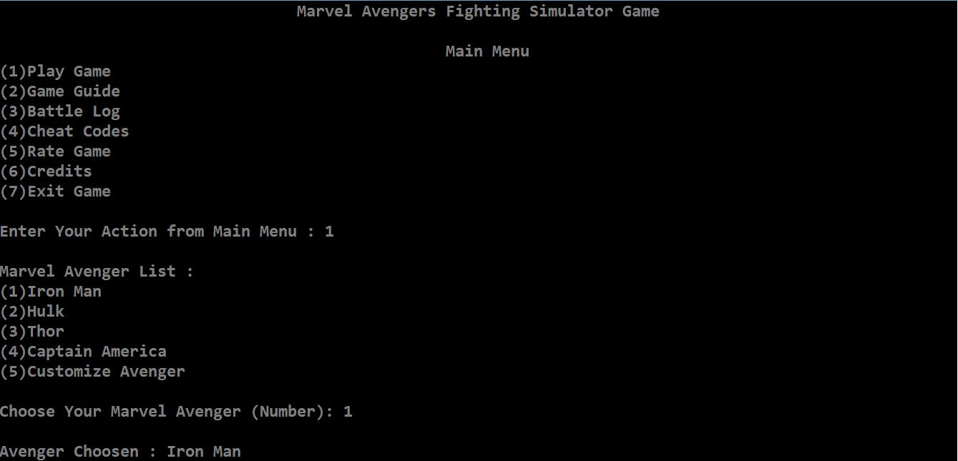

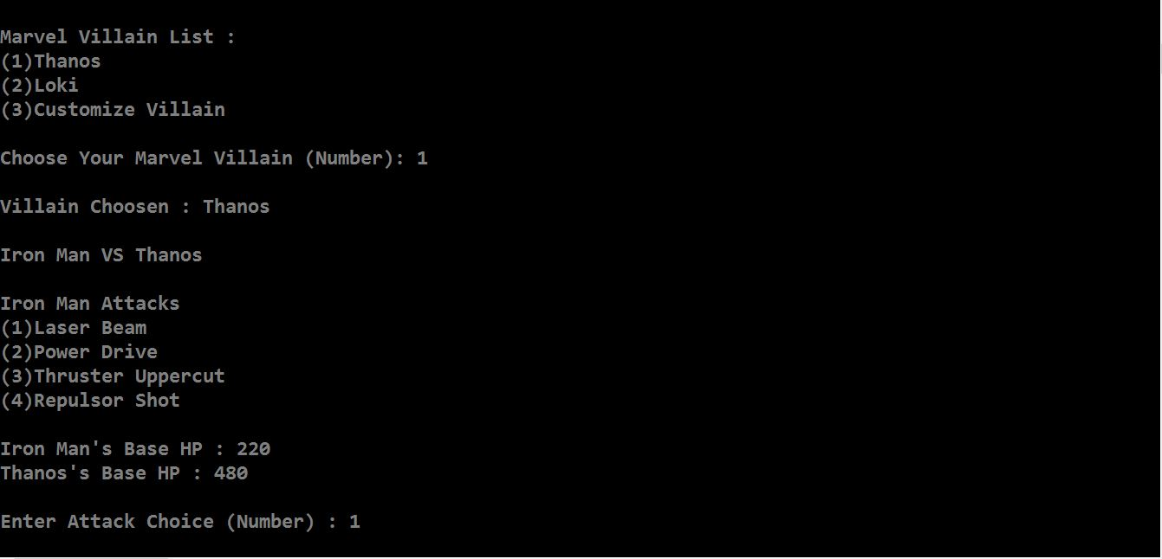

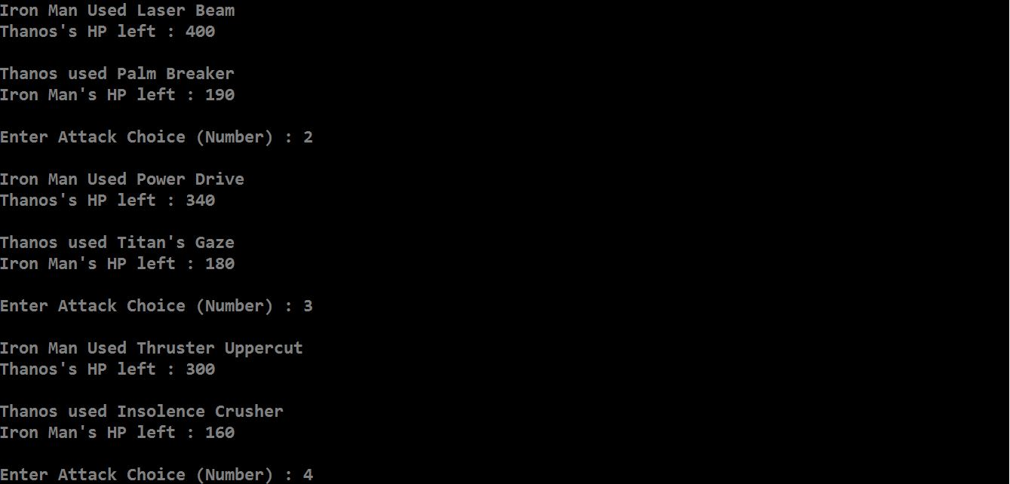

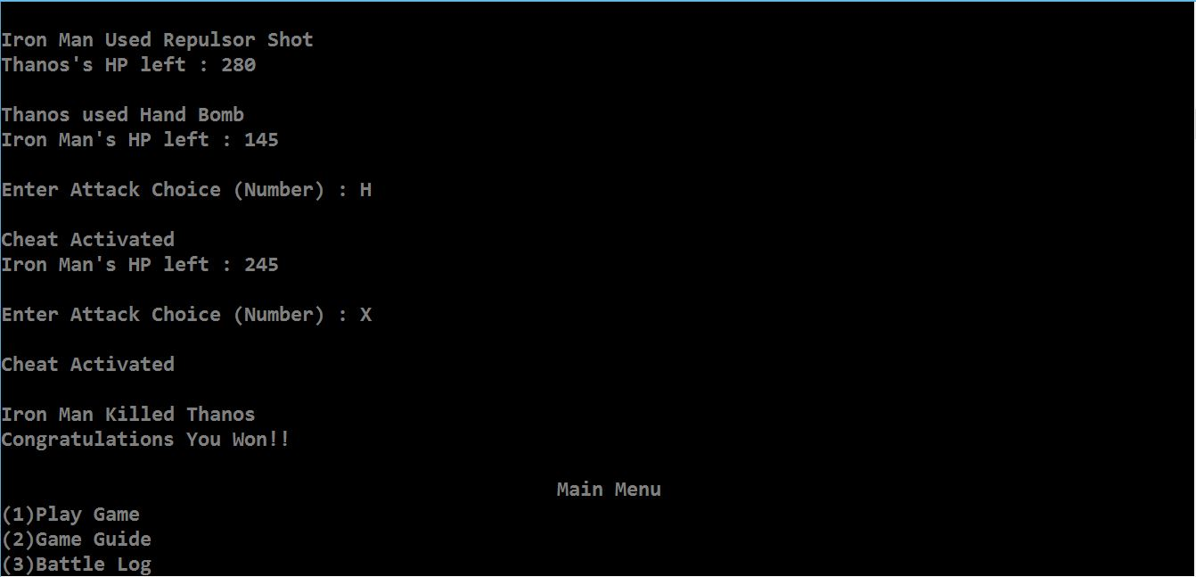

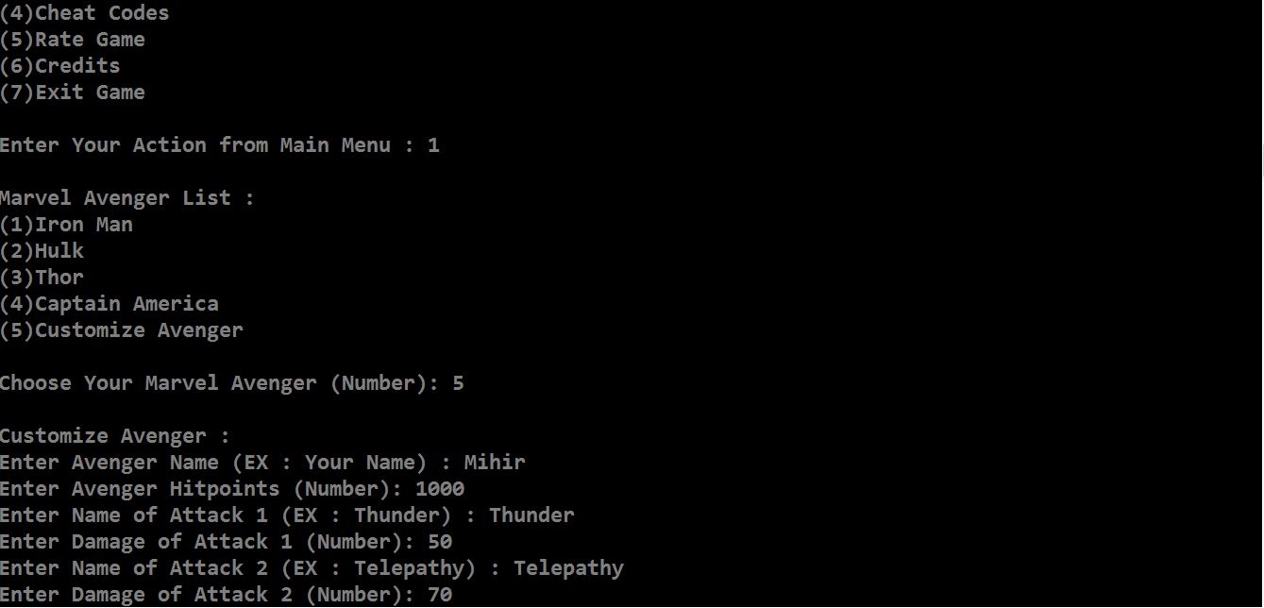

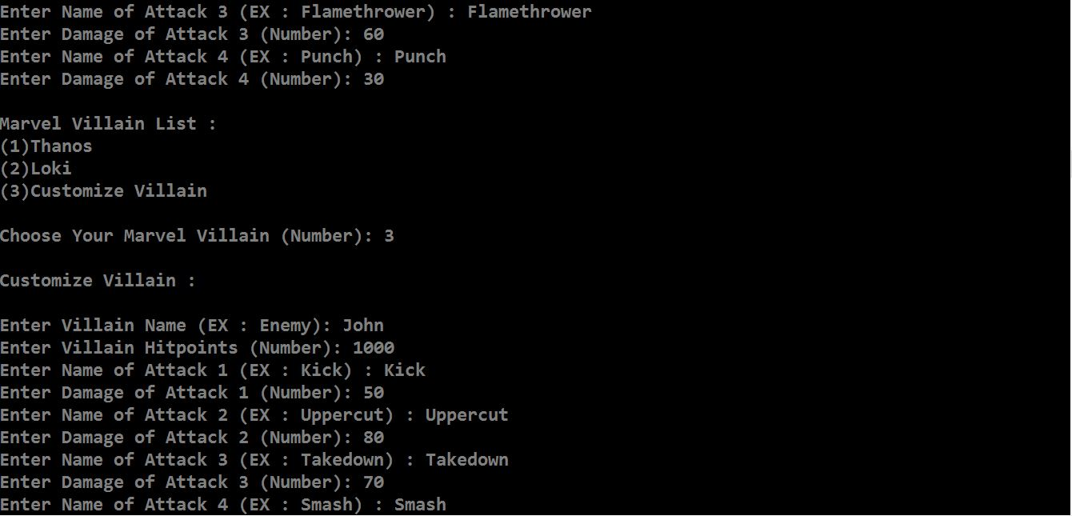

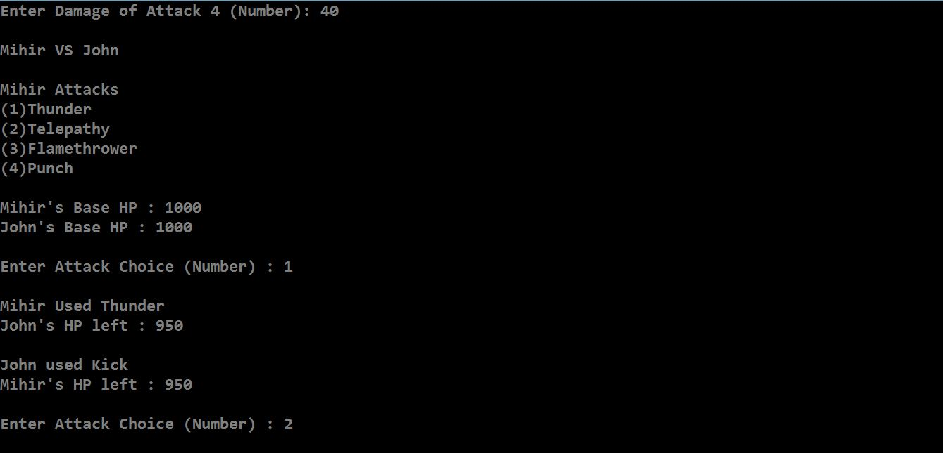

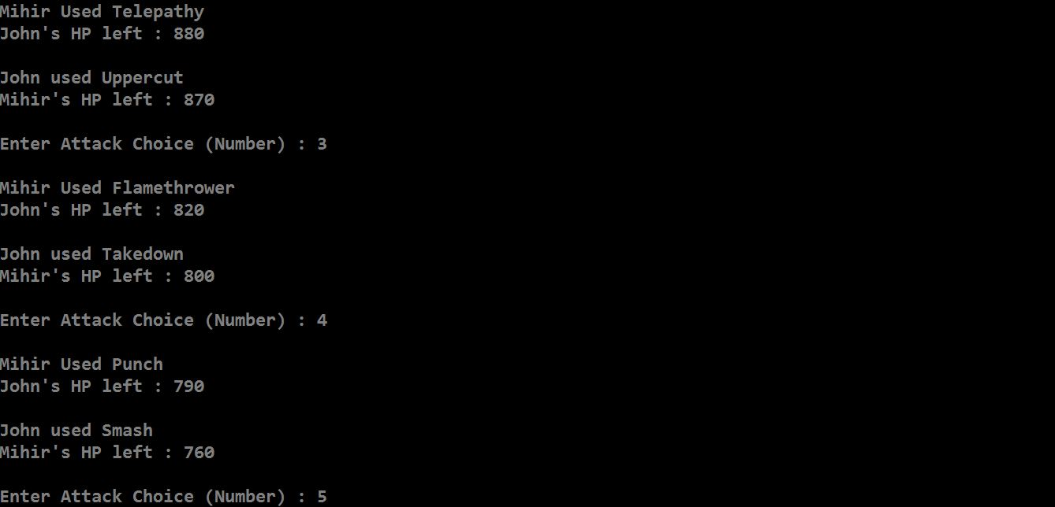

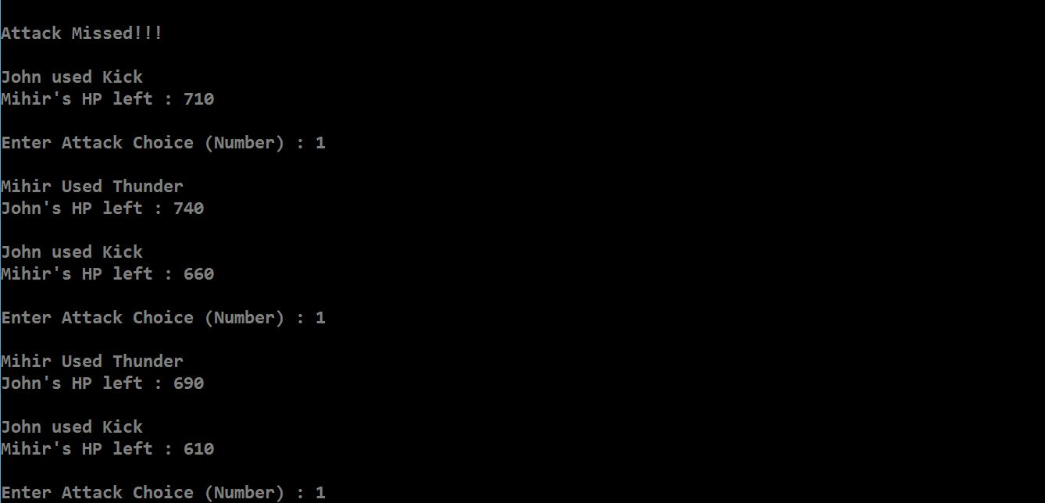

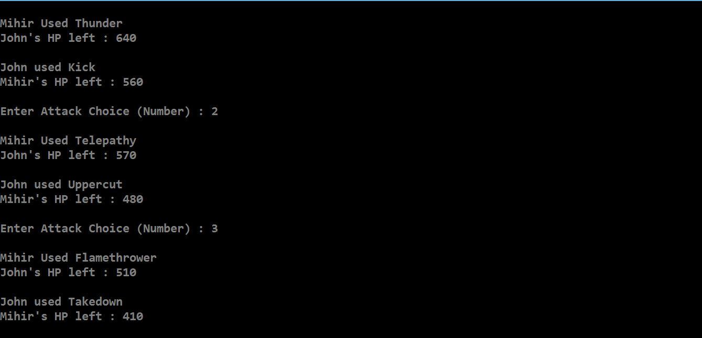

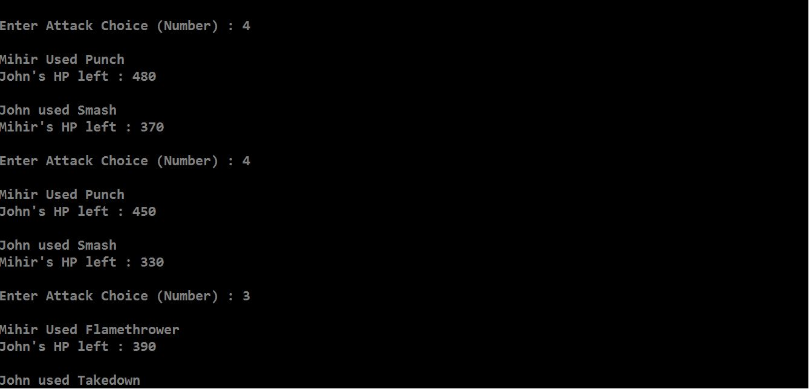

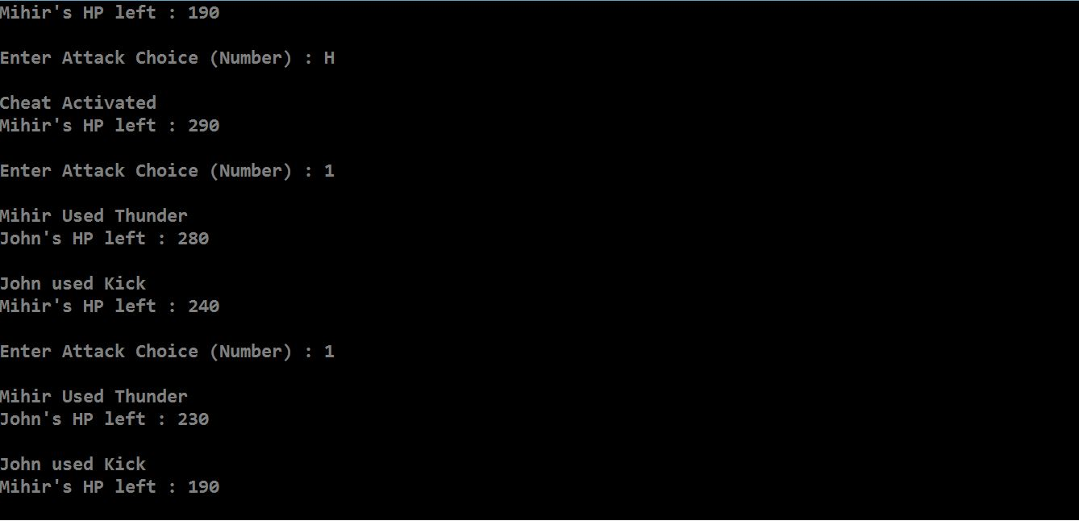

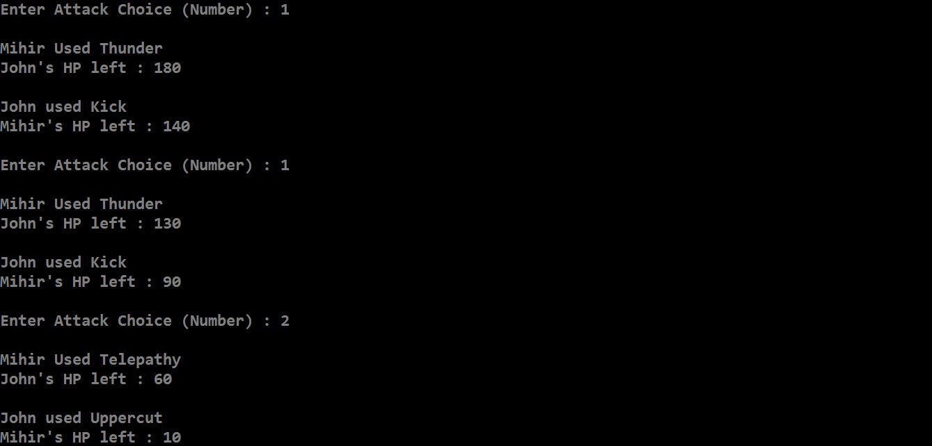

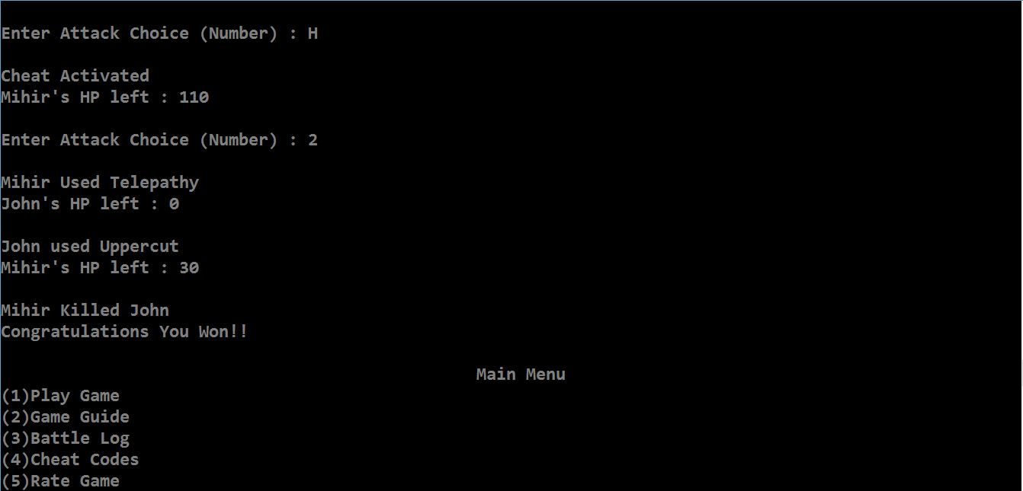

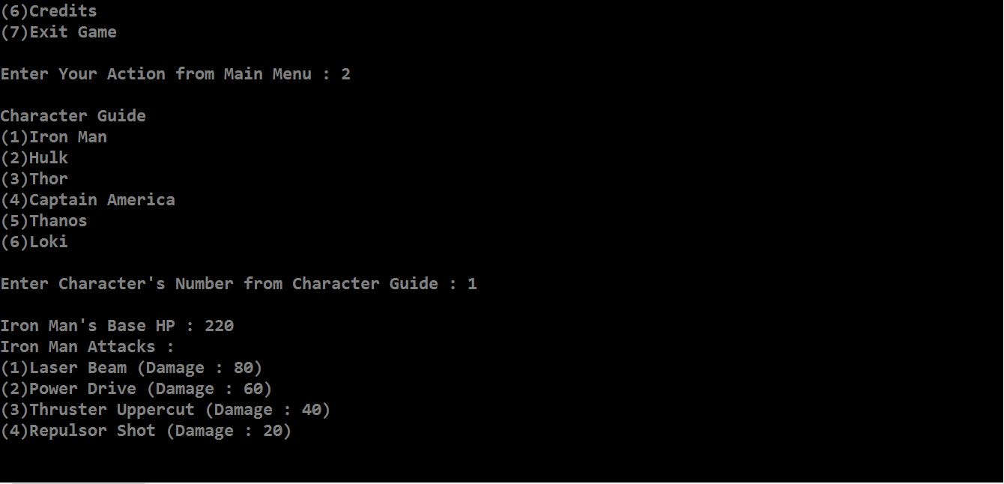

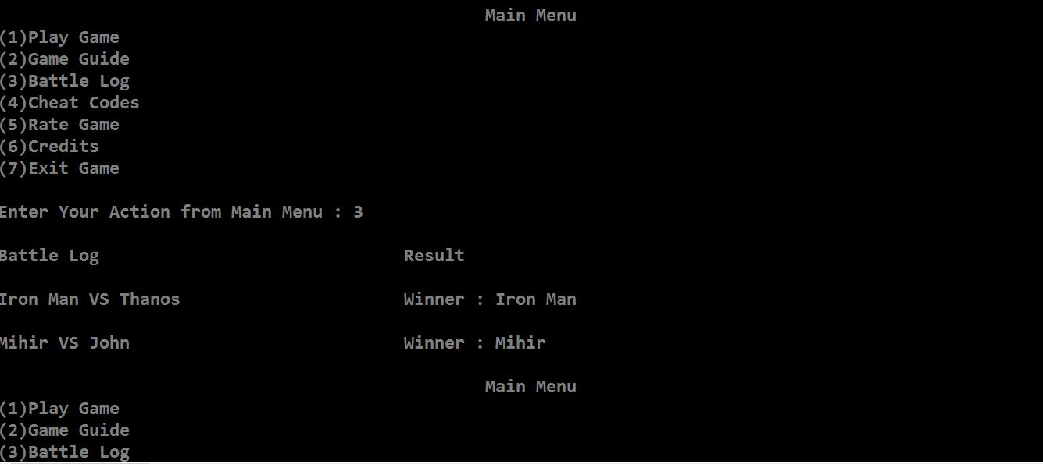

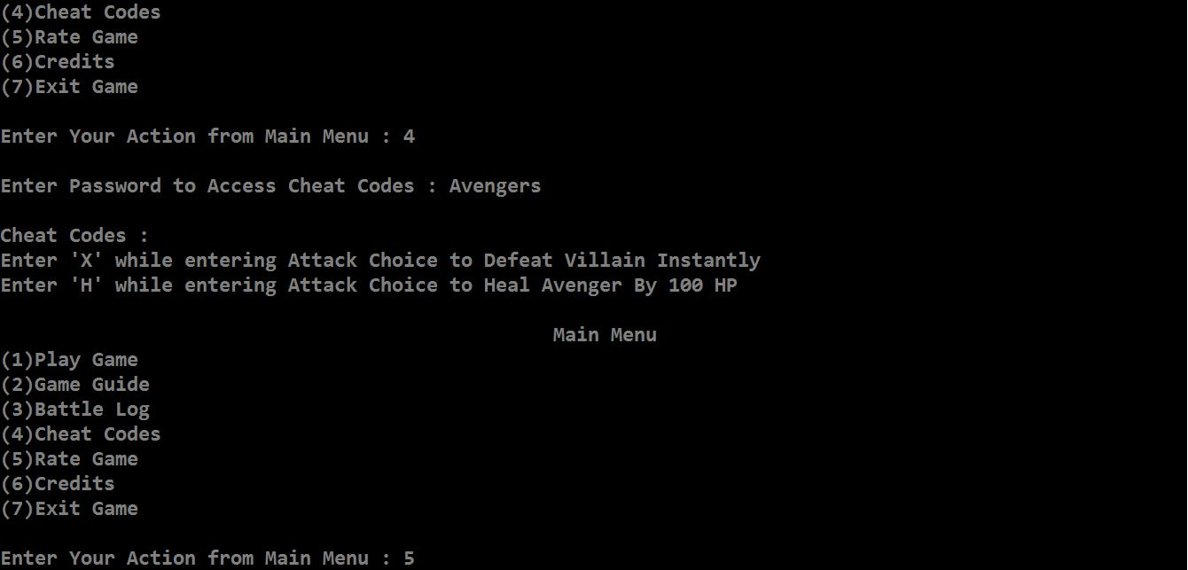

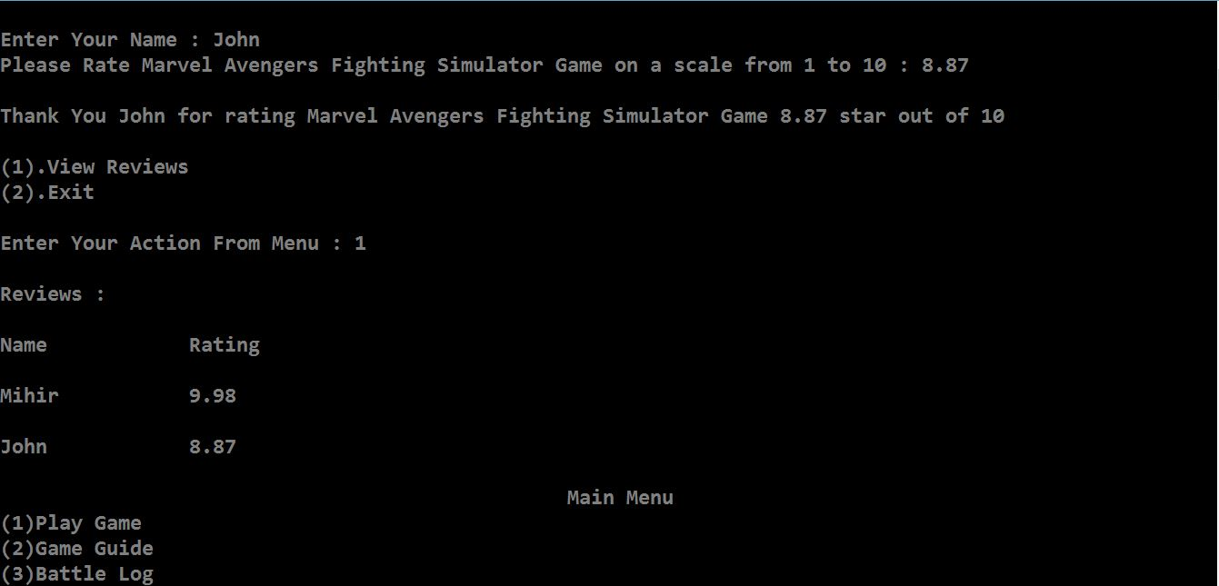

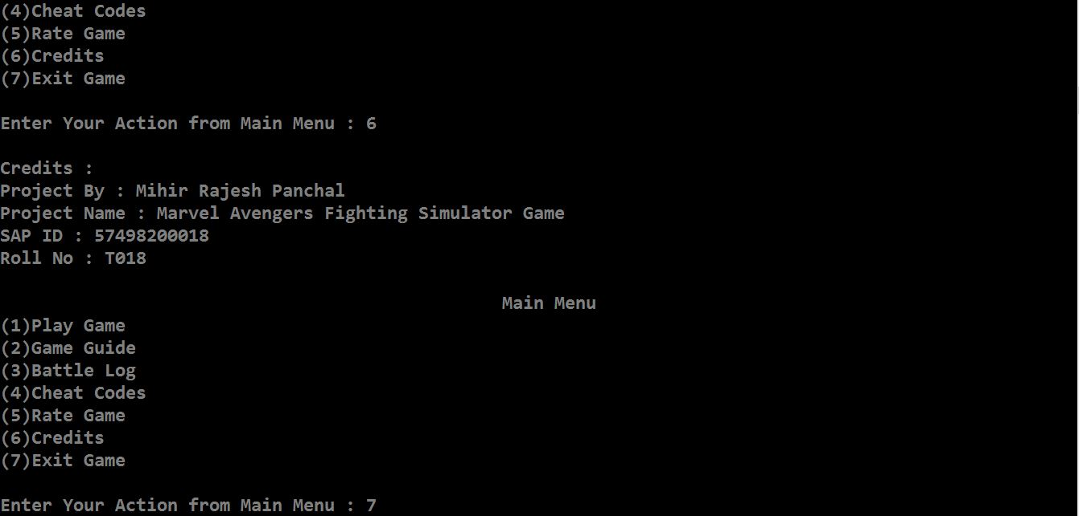

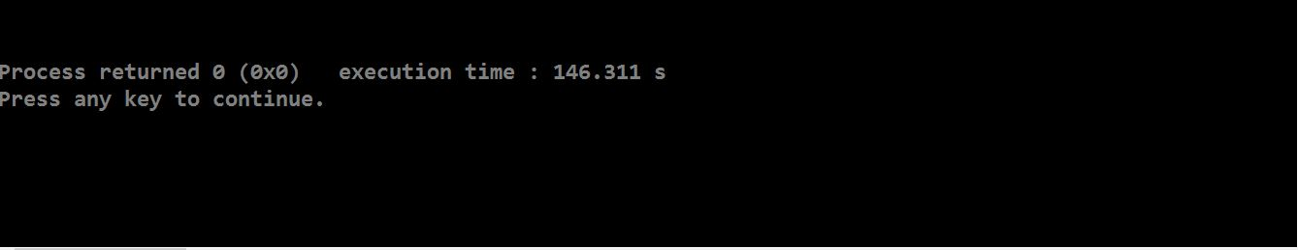

**6.CONCLUSION**

Through this Mini Project I was able to learn (more in depth) and implement C++ concepts altogether in a single program. Also, I was successful in debugging and solving errors in my program by using concepts learnt in the lectures conducted. This Mini Project can be compiled by Codeblocks And Dev C++ IDE.